TEACHER GUIDE

Distillation of a Mixture of Two Unknown Liquids

Students’ age
The experiment is suitable for upper secondary school students (16–19 years old) or undergraduate students in higher education.

Time required
120 minutes

Introduction
This experiment introduces risk assessment as a part of a standard distillation task. Details of the experiment, such as the amount of mixture to be used or the exact set up of the distillation apparatus are left open, because these details are dependent on the availability of lab equipment.

Lab equipment
Based on the availability of the lab equipment, you can change the suggested set up. For example, the distillation apparatus described in the student worksheet includes a fractional distillation column (Vigreux column), which is not necessary. As the difference of the boiling points of the liquids is high enough (over 25°C) simple distillation set up (without the fractional distillation column) can be used to separate the components.

Chemicals
- Mixture of water and acetone

Procedure

Pre-task
Table 1 is meant for collecting students’ assessments of physical hazards. After the identification of the liquids in the mixture they can also add chemical hazards to the table.
Table 1: List of significant physical hazards, which students might fill to Table 1. These are also somewhat dependent on the set up of the experiment.
List significant hazards | Describe what could happen | Precautionary measures | Measures to be taken if something goes wrong
Working with glassware (distillation apparatus) | Glass can shatter and cause cuts or eye injuries. | Handle glassware carefully. Wear protective goggles. First aid kit available to treat cuts. Emergency numbers for a medical help should be displayed somewhere, where everyone can see. | In case of cuts, stop bleeding and treat the cut. For cuts affecting only the top of the skin can be treated with the first aid kit. For deeper cuts of eye damage, always seek medical help from professionals.
Working with heat (heating mantle, heated up glassware) | Heat source and heated glass can lead to burns. | Work carefully. First aid kit available to treat burns. Emergency numbers for a medical help should be displayed somewhere, where everyone can see. | Cool the burn with cool or lukewarm running water for 20 minutes as soon as possible after the injury. Seeking medical help from professionals is always needed, if the burn is deep or on a large area.
Working with electricity and liquids (heating mantle, mixture of liquids, water running through Liebig condenser) | Faults or water in the heating mantle could lead to electric shock. If the mixture has flammable substances and ends up in the heating mantle, an electric spark might ignite it. | Work carefully. Use residual-current devices for heating mantles. Emergency switch should be in a place, where everyone can see and reach it. Water current flowing through the Liebig condenser should be as small as possible. Fire blanket should be placed somewhere, where everyone can see and reach it. | In case of electric shock or fire, use the emergency switch to switch off electricity first. In case of fire, extinguish the fire then (e.g., by using a fire blanket). Never use water to extinguish chemical or electrical fires! In case of electric shock, seeking medical help from professionals is always needed.

Experiment
If possible, provide students a photo or a drawing of the assembled distillation apparatus. Using a photo with the exact set up used is usually the best option. Check each set up before students can turn the heat on.
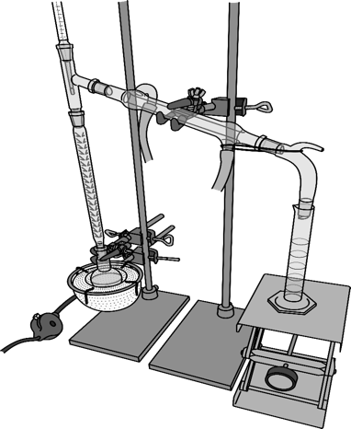
Figure 1: Drawn picture of the distillation apparatus.

Results and discussion
Table 2 presents the hazards of the possible liquids in the mixture.
Table 2: Hazards of the possible liquids in the mixture.
 | Hazard code | Scores (S) attributed to hazards*
 |  | Health | Environment | Physical
Liquids
diethyl ether | H224, H302, H336 | 2 | 1 | 3
dichloromethane | H315, H319, H335, H336, H351, H373 | 3 | 1 | 1
acetone | H225, H302, H319, H336, H373 | 3 | 1 | 3
methanol | H225, H301, H331, H311, H370 | 3 | 1 | 3
ethyl acetate | H225, H319, H336 | 2 | 1 | 3
water |  | 1 | 1 | 1
toluene | H225, H304, H315, H336, H361d, H373 | 3 | 1 | 3
* Scores attributed to hazards (S) - on a scale from 1 (low hazard) to 3 (high hazard)
When considering the less and most suited mixtures of liquid for this experiment attention should be paid especially to the health hazards. For example, although dichloromethane is not flammable it is suspected of causing cancer (351) and thus is not well suited for student lab experiments. The components of the solution should also be soluble to each other. Diethyl ether and ethyl acetate are only slightly soluble to water.

