STUDENT WORKSHEET – PART 1

Formation of hydrogen gas

Topics
Hydrogen gas formation from reacting metals with acid, optimizing a laboratory procedure, green chemistry principles.

Objectives
- Students learn that different acids and different metals react to produce hydrogen gas.
- Students learn that the combination of acid and metal and the concentration of the acid affects the rate of reaction.
- Students learn that the combination of acid and metal and the concentration of the acid affects the rate of reaction.
- Students learn how to optimize a laboratory procedure to achieve a suitable rate of reaction while minimizing chemical hazards.
- Students learn how to use principles of green chemistry to evaluate which of two laboratory procedures is most sustainable.

Introduction
Hydrogen gas can be produced in several ways. In school chemistry it is common to produce hydrogen gas by reacting a base metal with an acid. One common procedure is to let zinc metal react with hydrochloric acid:
Zn(s) + 2HCl(aq) → H₂(g) + ZnCl₂(aq)
Another common procedure is to let magnesium metal react with ethanoic acid (acetic acid):
Mg(s) + 2CH₃COOH(aq) → H₂(g) + Mg(CH₃COO)₂(aq)
Compared to magnesium, zinc is a less reactive metal, requiring the use of a stronger and/or more concentrated acid for the reaction to occur.

Lab equipment
- 100 mL graduated cylinder
- Test tubes with rubber stoppers with holes and tubing to collect gas
- 2 x ring stand with utility clamp
- 1000 mL beaker
- Scale

Chemicals
- Mg(s), magnesium
- Zn(s), zinc
- 6 M HCl(aq), hydrochloric acid
- 6 M CH₃COOH(aq), acetic acid

Safety information
Mandatory personal protective equipment: goggles, lab coat, and gloves. Before starting, it is necessary to carefully read the instructions for safe work. The waste must be handled properly /according to the description in the risk assessment (see the Teacher guide).

Procedure
- Calculate the mass of magnesium needed to produce 50 mL of hydrogen gas by reacting the magnesium with acetic acid.
- Set up the equipment to collect gas.
- Let the magnesium react with 6 M acetic acid in a test tube and collect the gas in the graduated cylinder.
- Use your knowledge of chemistry to optimize the procedure for the reaction between magnesium and acetic acid so that the reaction rate is suitable. Keep in mind the classification of the acid which you can find in the risk assessment.
- Repeat steps 1–4 for the reaction between zinc and hydrochloric acid.

Results and discussion
- Write down the optimized procedures in a way that another student could carry out the experiment using your instructions.
- Communicate your experimental results with presentations and reports using tables, graphs and/or charts.
- Use green metrics to evaluate the two procedures (see part 2).
- Present the two procedures and your evaluation of the experiment for another student or a group of students. Discuss similarities and differences in your results. Write down the two optimized procedures in a way that it could be read and understood by another student.

Conclusion
Summarize your findings presented in the Results and Discussion phase. Which of the procedures do you think is the most sustainable according to the principles of green chemistry?

STUDENT WORKSHEET – PART 2

Evaluation of experimental work with green chemistry metrics
Evaluate both experiments using green chemistry metrics. In this activity you will
- determine the hazards of the substances used in the experiment, thereby you will learn how to obtain and use safety data sheets and develop a practical understanding of hazard (H) and precautionary (P) statements
- determine the value of perceived greenness of the experiment, thereby you will be introduced to the 12 principles of green chemistry
- construct the green star of the experiment, thereby you will present the data obtained using graphical means to get a better overview of greenness of the experiment.
Follow the instructions below and use appendix 2–4 to help with the activity.

1. Determine the hazards of the substances used in experimental work
- In table 1, insert the names of the chemical compounds included in the experiment in the first column.
- For each chemical used, consult the safety data sheets you can obtain via the QR code in the risk assessment and write the hazard codes of each chemical in the second column.
- Use “Criteria to classify the hazards of substances” (appendix 2) to obtain scores* (1–3) attributed to health, environment, and physical hazards for each chemical used in the experiment. Insert the obtained scores in the appropriate (third/fourth/fifth) column. If no hazard code is assigned for a chemical, assign a score of 1.
Table 1: Hazards of the substances used in experimental work.
 | Hazard code | Scores (S) attributed to hazards*
 |  | Health | Environment |  | Physical
Stoichiometric reagents
Solvents and Auxiliary Substances
Product
Waste
* Scores (S) attributed to hazards on a scale from 1 (low hazard) to 3 (high hazard)

2. Determine the value of perceived greenness
- To fill table 2, see the appendix 2 “Green chemistry principles and assessment criteria for the value of perceived greenness (V)”.
- In this lab you should evaluate 10 principles of green chemistry, principle 1–3, 5–10 and 12.
- The value of perceived greenness (V) can be derived from appendix 4. V ranges from 1 (minimum) to 3 (maximum). Write NA when non applicable.
- Fill out one table for each of the two experiments.
Table 2: Green chemistry principles and the value of perceived greenness.
Green Chemistry Principle | Value of perceived greenness (V) | Explanation (optional)
P1 – prevention
P2 – atom economy*
P3 – less hazardous chemical synthesis*
P4 – designing safer chemicals**
P5 – safer solvents and auxiliary substances
P6 – increase energy efficiency
P7 – use renewable feedstocks
P8 – reduce derivatives*
P9 – catalysts*
P10 – design for degradation
P11 – real-time analysis for pollution prevention**
P12 – safer chemistry for accident prevention
* Applicable when using 10 or 12 principles. ** Applicable only when using all 12 principles

3. Construction of the green star
Construct a green star for both experimental protocols you have conducted.
- If you are constructing the green star on paper, colour the radar chart shown in figure 1a and 1b. Colour the area corresponding to a specific principle (e.g., P1, P2, etc.) based on the determined value V in table 2.
- If you have a computer, you can construct the green star in Excel and insert a copy of the green star in your worksheet.
  - Open appendix 1 (Excel file) and select “Green star (10 principles)”.
  - Use your results from table 2 to fill in the data in the green cells.
  - Copy the image of your green stars and replace the images bellow.

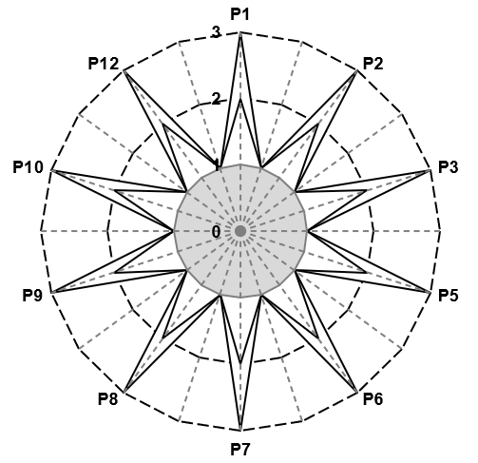
Figure 1a: Greenness assessment of the experimental work with magnesium and ethanoic acid (acetic acid).
Figure 1b: Greenness assessment of the experimental work with zinc and hydrochloric acid.

4. Consider further possibilities to optimize the experimental protocol
Could you use another metal and/or another acid with less hazardous properties? Could you find another protocol for producing hydrogen gas that is less hazardous?

References
Ribeiro, M. G. T., Costa, D. A., & Machado, A. A. (2010). “Green Star”: a holistic Green Chemistry metric for evaluation of teaching laboratory experiments. Green Chemistry Letters and Reviews, 3(2), 149-159. https://doi.org/10.1080/17518251003623376
Ribeiro, M. G. T., & Machado, A. A. (2014). Green star construction. http://educa.fc.up.pt/documentosQV/EV/Construction%20of%20Green%20Star_6_points_GSAI.xlsx

