TEACHER GUIDE – PART 1

Formation of hydrogen gas

Students’ age
The experiment is suitable for students 16–17 years old.

Time required
90 min

Theoretical introduction
Hydrogen gas can be produced in several ways. In school chemistry it is usual to produce hydrogen gas by reacting a base metal with an acid. One common procedure is to let zinc metal react with hydrochloric acid:
Zn(s) + 2HCl(aq) → H₂(g) + ZnCl₂(aq)
Another common procedure is to let magnesium metal react with ethanoic (acetic) acid:
Mg(s) + 2CH₃COOH(aq) → H₂(g) + Mg(CH₃COO)₂(aq)
Zinc is a less reactive metal than magnesium and it is therefore necessary to use a stronger and/or a more concentrated acid when the reaction is carried out with zinc metal compared to magnesium metal.
In school chemistry hydrogen gas can also be produced in at 2:1 ratio with oxygen by electrolysis of e.g., sodium sulfate solution. If green metrics are used on this reaction, it will come out as less hazardous than producing hydrogen gas by reacting a base metal with an acid.

Risk assessment
List significant hazards | Describe what could happen | Precautionary measures | Measures to be taken if something goes wrong
Acetic acid 4.1 M < c < 6 M | 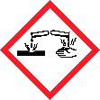  H314 Causes severe skin burns and eye damage. | Wear eye protection. | IF SWALLOWED: Rinse mouth. Do NOT induce vomiting. IF ON SKIN (or hair): Take off immediately all contaminated clothing. Rinse skin with water [or shower]. IF IN EYES: Rinse cautiously with water for several minutes. Remove contact lenses, if present and easy to do. Continue rinsing. Immediately call a doctor.
Acetic acid 1.6 M < c < 4.1 M | H315 Causes skin irritation.  H319 Causes serious eye irritation. | Wear eye protection. | IF IN EYES: Rinse cautiously with water for several minutes. Remove contact lenses, if present and easy to do. Continue rinsing. If eye irritation persists: Get medical attention.
Hydrochloric acid 2.7 M < c < 6 M | H315 Causes skin irritation.  H319 Causes serious eye irritation.  H335 May cause respiratory irritation. | Wear eye protection. | IF IN EYES: Rinse cautiously with water for several minutes. Remove contact lenses, if present and easy to do. Continue rinsing. If eye irritation persists: Get medical attention.
Zinc | 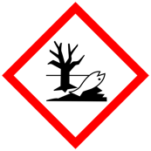  H410 Very toxic to aquatic life with long lasting effects. | Collect spillage. Avoid release to the environment. | -
Magnesium ribbon | 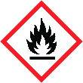  H228 Flammable solid.  H252 Self-heating in large quantities; may catch fire.  H261 In contact with water releases flammable gases. | Keep away from heat, hot surfaces, sparks, open flames, and other ignition sources. No smoking. In case of fire: Use dry sand, dry chemical, or alcohol-resistant foam to extinguish. | -
Hydrogen gas | H220 Extremely flammable gas | Keep away from heat/sparks/open flames/hot surfaces. No smoking. | -

Disposal and any other comments | Reaction products should be disposed in accordance with instructions written in SDS and local/regional/national/international regulations.  Students should wear personal protective equipment (goggles and lab coat).
In case of emergency | In case of emergency call 112 or personal doctor.

Date of assessment | 20.4.23 | Written by | CheSSE | Class / lesson | EXAMPLE

Results and discussion (Example)
The students write the protocols for the two different ways of producing hydrogen gas, Students communicate their experimental results with presentations and reports using tables, graphs and/or charts. Circulate among the student’s asking questions and offering them help with organizing experimental data.
Students use green metrics to evaluate the two experiments. They also present their result for peers and interpret their research results. Interaction among student groups is important as well as collection of information that will be utilized during the Conclusion phase.

Conclusion
In this phase student summarize the results presented in the Results and Discussion phase.

TEACHER GUIDE – PART 2

Evaluation of experimental work with green chemistry metrics (sample results)
Evaluate both experiments using green chemistry metrics. In this activity you will
- determine the hazards of the substances used in the experiment, thereby you will learn how to obtain and use safety data sheets and develop a practical understanding of hazard (H) and precautionary (P) statements
- determine the value of perceived greenness of the experiment, thereby you will be introduced to the 12 principles of green chemistry
- construct the green star of the experiment, thereby you will present the data obtained using graphical means to get a better overview of greenness of the experiment.
Follow the instructions below and use appendix 2, 3 and 4 to help with the activity.

1. Determine the hazards of the substances used in experimental work
- In table 2, insert the names of the chemical compounds included in the experiment in the first column.
- For each chemical used, consult the safety data sheets you can obtain via the QR code in the risk assessment and write the hazard codes of each chemical in the second column.
- Use appendix 2 to obtain scores* (1–3) attributed to health, environment, and physical hazards. Insert the obtained scores in the appropriate column. If no hazard code is assigned for a chemical, assign a score of 1.
Table 1: Hazards of the substances used in experimental work. In this example 2 M acetic acid and 4 M hydrochloric acid is used.
All chemicals used  and generated | Hazard code | Scores (S) attributed to hazards*
 |  | Health | Environment | Physical
magnesium turning | H228, H252, H261 | 1 | 1 | 3
zinc metal | H400, H410 | 1 | 3 | 1
2 M acetic acid | Not classified as a hazardous mixture | 1 | 1 | 1
4 M hydrochloric acid | H315, H319, H335 | 2 | 1 | 1
zinc chloride | H400, H410 | 1 | 3 | 1
Hydrogen gas | H220 | 1 | 1 | 3
magnesium acetate | Not classified as hazardous | 1 | 1 | 1
* Scores (S) attributed to hazards on a scale from 1 (low hazard) to 3 (high hazard)

2. Determine the value of perceived greenness
- To fill table 2, see the Green Chemistry Principles and Criteria for assessment of the value of perceived greenness (appendix 2).
- In this lab you should evaluate 10 principles of green chemistry, principle 1–3, 5–10 and 12.
- The value of perceived greenness (V) can be derived from appendix 4. V ranges from 1 (minimum) to 3 (maximum). Write NA when non applicable.
- Fill out one table for each of the two experiments.

Zinc and 4M hydrochloric acid
Table 2: Perceived greenness – zinc and 4 M hydrochloric acid.
Green Chemistry Principle | Value of perceived greenness (V) | Explanation (optional)
P1 – prevention | 1 | ZnCl₂(aq)
P2 – atom economy* | 1 | Excess of HCl (> 10 %) and formation of by-product (ZnCl₂)
P3 – less hazardous chemical synthesis* | 1 | Use of Zn and ZnCl₂
P4 – designing safer chemicals** | NA
P5 – safer solvents and auxiliary substances | 3 | No solvent other than water used
P6 – increase energy efficiency | 3 | Room temperature and pressure 1 atm (STP)
P7 – use renewable feedstocks | 2 | Hydrochloric acid is renewable
P8 – reduce derivatives* | 3 | One step
P9 – catalysts* | 1 | No catalyst
P10 – design for degradation | 1 | All substances are not degradable
P11 – real-time analysis for pollution prevention** | NA
P12 – safer chemistry for accident prevention | 1 | H₂
* Applicable when using 10 or 12 principles. ** Applicable only when using all 12 principles

Magnesium and 2M acetic acid
Table 3: Perceived greenness – magnesium and 2M acetic acid
Green Chemistry Principle | Value of perceived greenness (V) | Explanation (optional)
P1 – prevention | 3 | Magnesium is reused and not considered waste
P2 – atom economy* | 1 | Excess of acetic acid (> 10 %) and formation of by-product (magnesium acetate)
P3 – less hazardous chemical synthesis* | 1 | Magnesium metal
P4 – designing safer chemicals** | NA
P5 – safer solvents and auxiliary substances | 3 | No solvent other than water used
P6 – increase energy efficiency | 3 | Room temperature and pressure
P7 – use renewable feedstocks | 2 | Acetic acid is renewable
P8 – reduce derivatives* | 3 | One step
P9 – catalysts* | 1 | No catalyst
P10 – design for degradation | 1 | All substances are not degradable
P11 – real-time analysis for pollution prevention** | NA
P12 – safer chemistry for accident prevention | 1 | Magnesium metal, hydrogen gas
* Applicable when using 10 or 12 principles. ** Applicable only when using all 12 principles

3. Construction of the green star
The green star presents the results of the greenness assessment of the experimental protocol.
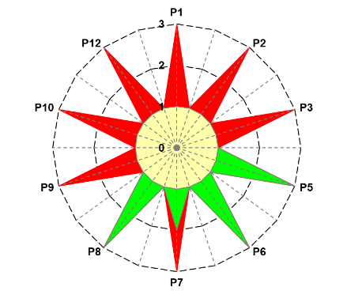
Figure 1a: Greenness assessment of the experimental work experimental work with 4 M hydrochloric acid and zinc.
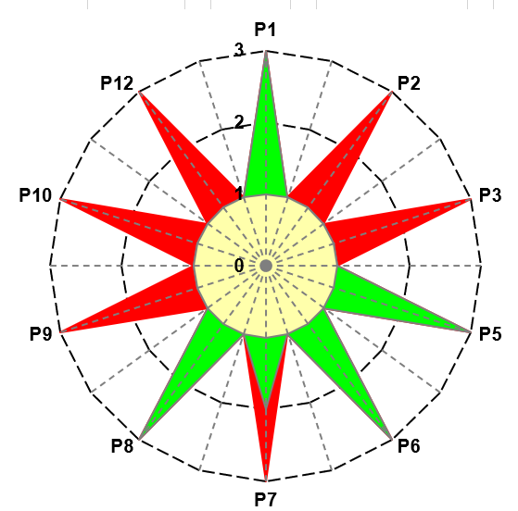
Figure 1b: Greenness assessment of the experimental work with 2 M acetic acid and magnesium.

4. Consider further possibilities to optimize the experimental protocol
Could you use another metal and/or another acid with less hazardous properties? Could you find another protocol for producing hydrogen gas that is less hazardous?

References
Ribeiro, M. G. T., Costa, D. A., & Machado, A. A. (2010). “Green Star”: a holistic Green Chemistry metric for evaluation of teaching laboratory experiments. Green Chemistry Letters and Reviews, 3(2), 149-159. https://doi.org/10.1080/17518251003623376
Ribeiro, M. G. T., & Machado, A. A. (2014). Green star construction. http://educa.fc.up.pt/documentosQV/EV/Construction%20of%20Green%20Star_6_points_GSAI.xlsx

