Note: This is a template. Delete this red text in your finished version. Before use, the text below must be adapted to the local conditions at the school. For example, if a different type of gas burner is used, adapt the instructions for handling below.

Gas Burner Instructions

Introduction
In some lab tasks you need to heat different substances with a gas burner. To get a gas burner certificate, you need to learn about
- the gas burner’s function
- potential risks
- how to handle the gas burner
- what to do in case of a fire

Material
Gas burners, long matches or long-handled lighter or splints, necessary protective equipment, e.g. fire blanket and oven mittens.

Theoretical part – answer the following:
- List the fire safety equipment in your classroom and where it is located
- How should the equipment be used, and by whom?
- Where are the emergency exits located?
- Where is the fire alarm located?
- What are the potential risks when using a burner?
- In case of an emergency / in case of a fire, what do you do?

Practical part
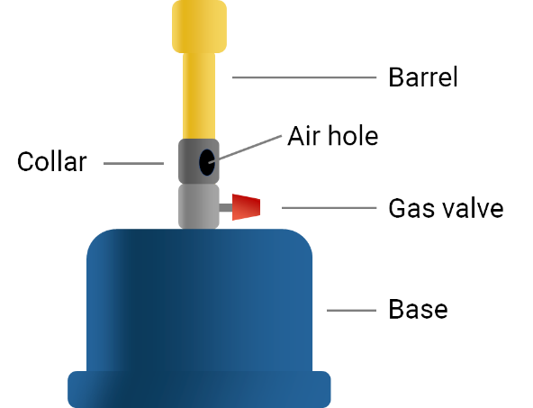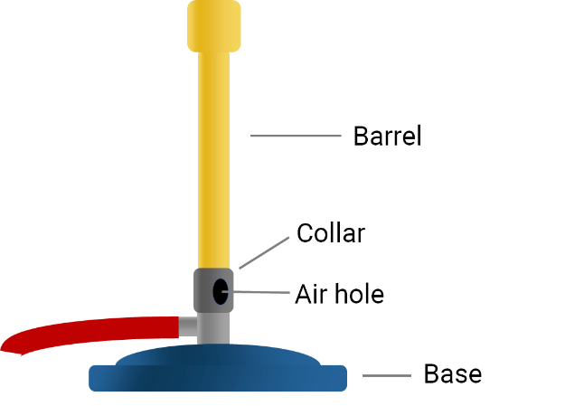
Perform the following steps under the supervision of your teacher:
- Make sure the lab bench is uncluttered and clear of all flammable and combustible materials.
- Tie up long hair, tuck in or remove loose clothing, and take off dangling jewellery.
- Handle the burner by the base.
- Place the burner on a heat proof surface.
- Adjust the air supply by turning the collar so the air holes are slightly open.
- Light a match and hold the flame over the top of the barrel. Open the gas valve, and the match flame will ignite the gas. After the burner is lit, extinguish the match.
- When not used for heating, the gas should burn with a yellow, luminous flame. This is called a safety flame.
- Twist the collar to adjust the flame’s temperature. The more air, the hotter is the flame. As the flame gets hotter it turns blue. Beware that at its hottest the flame is almost invisible.
- Adjust the gas valve until you have adjusted your flame to the appropriate size for your task. More gas will create a larger flame, and less gas gives a smaller flame.
- Never leave a lit burner unattended, and always turn the burner off when it is not in use.
- Cut off the gas supply by closing the valve completely.
- Check with a long match that there is no flame that can ignite.
- The barrel of the burner may remain hot for some time after the burner has been used. Wait for the burner to cool before putting it away.
- Repeat everything in front of your teacher who will check that you know the procedure. Once you have gone through all the steps successfully, you will get a certificate for using the burner.

