Teacher Guide – part 1

Getting to know the Chemical Nature of Everyday Substances
This teaching unit is designed as Step-by-Step Instruction. Students will find out more about different ways to determine the pH of everyday substances through experimental work and by using textbooks and other available sources.
Students’ age
The experiment is suitable for students in the 8th grade (13–14 years old).

Time required
90 min

Curricular relevance
According to the Slovenian Chemistry Curriculum for Primary School (Chemistry Curriculum for Primary School, 2011).
- Students should be able to distinguish between acidic, basic, and neutral substances from everyday life and determine the pH value.
- Students are encouraged to develop experimental-research skills.
- Students should understand the interdependence of the structure, properties, and uses of chemical compounds.
- Students develop responsible attitude towards use of chemical compounds and their consequences for health and the environment (chemical safety).
- Students are encouraged to observe systematically and use observations as a source of data.

Introduction
We encounter acids and bases in everyday life. Our senses can immediately recognise lemon juice, vinegar, or apples as acidic. But not all substances we use in everyday life can be tested with our senses, e.g., for their acidity.
pH is a logarithmic scale that gives a quantitative measure of the acidity or alkalinity of an aqueous solution. The pH value is a measure of the concentration of hydrogen ions (H⁺) in a solution, and ranges between 0 and 14. The lower the pH value, the more acidic the solution; the higher the pH value, the more basic the solution.
There are various methods for determining the pH value, e.g., the use of pH meters, pH indicators and pH test papers. Each of these methods has its own advantages, so we must weigh up which of the methods is most suitable for our experiment.
A pH indicator is a substance that changes colour depending on the pH of the solution. This is a way to visually determine the pH. pH indicators are a good way to quickly and easily determine the approximate pH compared to a standard by colour. The indicator used in this experiment is obtained from a natural source, red cabbage, and has a certain colour depending on the pH of the solution.
While pH indicators are useful for qualitative purposes, a pH metre is used when an accurate quantitative value is needed. A laboratory pH meter usually has a special probe with a membrane that responds to H⁺ ion concentrations. The meter displays the exact pH value of the solution under investigation.

Risk Assessment
List significant hazards | Describe what could happen | Precautionary measures | Measures to be taken if something goes wrong
universal indicator solution | H226 Flammable liquid and vapour.  H303 + H313 May be harmful if swallowed or in contact with skin.  H320 Causes eye irritation. | P210 Keep away from heat, sparks, open flames, hot surfaces. No smoking.

Disposal and any other comments | Reaction products should be disposed in accordance with instructions written in SDS and local/regional/national/international regulations.  Students should wear personal protective equipment (gloves, goggles, and lab coat).
In case of emergency | In case of emergency call 112 or personal doctor.

Date of assessment | 13-2-2023 | Written by | CheSSE | Class / lesson | EXAMPLE

Example answers to the questions
- What is the pH value of a solution? A pH value is a number between 0 and 14 that indicates the acidity or alkalinity of a solution. The pH values of everyday substances range from pH 0 and pH 14. The lower the pH value, the more acidic the solution; the higher the pH value, the more basic the solution.
- Name at least three ways to determine the pH of a solution. The use of pH meter, pH indicators and pH test papers.
- How does a pH meter work? A pH meter is a device that is used to determine the pH value of solutions. It is an electronic device and has a special bulb that is sensitive to the hydrogen ions that are present in the solution. The electronic bulb produces a signal which then gets amplified and is shown in a meter format in the electronic meter. For a precise measurement, the pH meter needs to be calibrated before every measurement.
- What is universal indicator solution and why can it be used to determine the pH of a solution? Universal indicator is a mixture of indicators made in such a way as to give, as far as possible, a different colour for each pH unit.
- Why can red cabbage solution be used to determine the pH of a solution? Red cabbage contains a chemical called anthocyanin. This pigment is a natural acid-base indicator.

Results and Discussion (example)
Students organize, interpret, and communicate experimental results using tables, graphs and/or charts.

Part A: Determining pH of everyday substances with pH meter (optionally various kinds of school equipment that enable pH measuring)
Table 1: Results of determining pH of everyday substances with pH meter (optionally: various kinds of school equipment that enable pH measuring).
Sample | Measured pH
1 – lemon juice | 2.2
2 – vinegar | 2.8
3 – baking powder solution | 8.3
4 – laundry washing powder solution | 9.2
5 – bottled water | 6.7

Part B: Determining pH of everyday substances with universal indicator solution
Table 2: Results of determining pH of everyday substances with universal indicator solution
Sample | Observations | Conclusions
1 – lemon juice | The colour of universal indicator solution changed from dark green to pink. | Solution is acidic.
2 – vinegar | The colour of universal indicator solution changed from dark green to orange. | Solution is acidic.
3 – baking powder solution | The colour of universal indicator solution changed from dark green to turquoise. | Solution is alkaline.
4 – laundry washing powder solution | The colour of universal indicator solution changed from dark green to turquoise. | Solution is alkaline.
5 – bottled water | The colour of universal indicator solution changed from dark green to lime green. | Solution is slightly acidic.

Part C: Determining pH of everyday substances with red cabbage solution
Table 3: Results of determining pH of everyday substances with universal indicator solution.
Sample | Observations | Conclusions
1 – lemon juice | The colour of red cabbage solution changed from dark purple to red. | Solution is acidic.
2 – vinegar | The colour of red cabbage solution changed from dark purple to red. | Solution is acidic.
3 – baking powder solution | The colour of red cabbage solution changed from dark purple to blue. | Solution is alkaline.
4 – laundry washing powder solution | The colour of red cabbage solution changed from dark purple to green. | Solution is alkaline.
5 – bottled water | The colour of red cabbage solution changed from dark purple to dark pink. | Solution is slightly acidic.

Conclusion (example)
In this phase student summarize the results presented in the Results and Discussion phase.
Substances from everyday life can be acidic, alkaline, or neutral. We can determine the pH of a solution of everyday substance with pH meter, a universal indicator solution or a red cabbage solution. The results of the experiments show that lemon juice and vinegar are acidic, baking powder solution and laundry washing powder solution alkaline and bottled water is slightly acidic.

Teacher Guide – part 2

Evaluation of experimental work with green chemistry metrics (sample results)
Evaluate the experiment the Getting to know the chemical nature of everyday substances using green chemistry metrics. In this activity you will
- determine the hazards of the substances used in the experiment, thereby you will learn how to obtain and use safety data sheets and develop a practical understanding of hazard (H) and precautionary (P) statements
- determine the value of perceived greenness of the experiment, thereby you will be introduced to the 12 principles of green chemistry
- construct the green star of the experiment, thereby you will present the data obtained using graphical means to get a better overview of greenness of the experiment.
Follow the instructions below and use appendix 2, 3, and 4 to help with the activity.

1. Determine the hazards of the substances used in experimental work
- In table 1, insert the names of the chemical compounds included in the experiment in the first column.
- For each chemical used, consult the safety data sheets you can obtain via the QR code in the risk assessment and write the hazard codes of each chemical in the second column.
- Use appendix 2 to obtain scores* (1–3) attributed to health, environment, and physical hazards. Insert the obtained scores in the appropriate column. If no hazard code is assigned for a chemical, assign a score of 1.
Table 1: Hazards of the substances used in experimental work, according to the protocol described in the procedure (part A, part B, part C).
 | Hazard code | Scores (S) attributed to hazards*
 |  | Health | Environment |  | Physical
Part A: Determining pH of everyday substances with pH meter
– | – | – | – | –
Part B: Determining pH of everyday substances with universal indicator solution
universal indicator solution | H226, H303, H313, H320 | 2 | 1 | 2
Part C: Determining pH of everyday substances with red cabbage solution
red cabbage solution | – | – | – | –
Part A, B, and C
1 – lemon juice | – | – | – | –
2 - vinegar | – | – | – | –
3 – baking powder solution | – | – | – | –
4 – laundry washing powder solution | – | – | – | –
5 – bottled water | – | – | – | –
* Scores (S) attributed to hazards on a scale from 1 (low hazard) to 3 (high hazard)

2. Determine the value of perceived greenness
- To fill table 2, see the Green Chemistry Principles and Criteria for assessment of the value of perceived greenness (appendix 2).
- Decide the number of principles (e.g., 6 or 10 principles) that provides the most meaningful evaluation of perceived greenness of the experiment.
- The value (V) of perceived greenness can be derived from appendix 2. V ranges from 1 (minimum) to 3 (maximum). Write NA when non applicable.
Table 2: Green Chemistry Principles and the value of perceived greenness to contruct the green star of the experimental work, described in the procedure (part A, part B, part C).
Green Chemistry Principle | V (PART A) | V (PART B) | V (PART C)
P1 – prevention | 3 | 2 | 3
P2 – atom economy*
P3 – less hazardous chemical synthesis*
P4 – designing safer chemicals**
P5 – safer solvents and auxiliary substances | NA | NA | NA
P6 – increase energy efficiency | NA | NA | NA
P7 – use renewable feedstocks | NA | NA | NA
P8 – reduce derivatives*
P9 – catalysts*
P10 – design for degradation | 3 | 2 | 3
P11 – real-time analysis for pollution prevention**
P12 – safer chemistry for accident prevention | 3 | 2 | 3
* Applicable when using 10 or 12 Principles. ** Applicable only when using all 12 Principles

3. Construction of the green star
The green star presents the results of the greenness assessment of the experimental protocol.
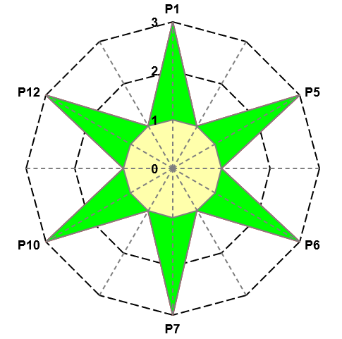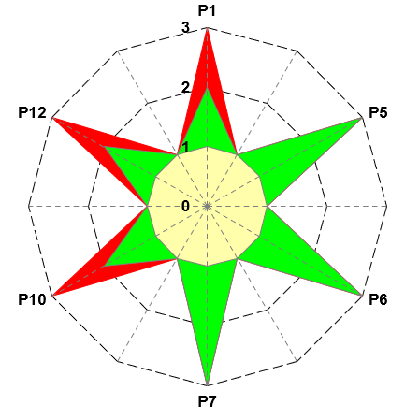
Figure 2: Greenness assessment of the experimental work, part A, B and C.

4. Reflect on the results of the evaluation of experimental protocols with green chemistry metrics
What are the advantages and disadvantages of using a particular method to determine the pH of a solution?

References
Ribeiro, M. G. T., Costa, D. A., & Machado, A. A. (2010). “Green Star”: a holistic Green Chemistry metric for evaluation of teaching laboratory experiments. Green Chemistry Letters and Reviews, 3(2), 149-159. https://doi.org/10.1080/17518251003623376
Ribeiro, M. G. T., & Machado, A. A. (2014). Green star construction. http://educa.fc.up.pt/documentosQV/EV/Construction%20of%20Green%20Star_6_points_GSAI.xlsx

