Student Worksheet – part 1

Synthesis and Analysis of Bioplastics

Topics
Bioplastics, chemical bonds and degradation, sustainable development, and spectrophotometry.

Objectives
- To synthesize and analyse three bioplastics, in a safe and systematic way, and compare the degradation to commonly used plastics.
- To use spectrophotometry and theory of chemical bonding to assess which bioplastic is degradable.
- To understand the relationship between the structure, properties, and uses of chemical compounds, and their effects on health and the environment.
- To discuss the advantages and disadvantages of non-degradable and degradable plastics.
- To use the principles of green chemistry focusing on the use of renewable raw materials and design for decomposition.

Introduction

Overall structure of the experiment
Part 1 – Practical work
- 1A Synthesis of three different bioplastics
- 1B Qualitative observation of the degradation of common plastics, e.g., PET and PLA
- 1C Analysis of the degradation of the synthesised bioplastics from 1A
Part 2 – Evaluation of experimental work with green chemistry metrics (theoretical)

Bioplastics
Plastics or synthetic polymers are materials that appear everywhere in our daily lives. Think of the mobile phone in your hand, the packaging you get when you order things on the internet or buy your lunch meal. The properties of these materials, their strength, resistance to temperature changes, flexibility, and the ability to be moulded into different shapes, makes them necessary for modern society. Currently, the vast majority of plastic originates from non-renewable fossil fuels, that rapidly depleting. Since 1950, the annual global plastic production has increased from 2 to 380 million tonnes and is expected to double by 2035 and nearly quadruple by 2050. The accumulation of plastic both on land and in water, causes harmful effects on people, animals, and the environment is concerning. Even though much of the plastic can be recycled, less than 10 % of the total plastic waste generated in 2014, was recycled (Parker, 2018). If not collected and recycled, non-degradable plastics will persist for centuries. The objective of this laboratory work is to investigate the production and degradation of bioplastics and the degradation of common plastics.

Bioplastic from citric acid and glycerol
Bioplastic can be formed from citric acid and glycerol, as shown in figure 1. The carboxylic acid groups in the citric acid reacts with the OH-groups in the glycerol and form ester bonds, where water is eliminated. Strong heating and longer reaction time are needed to drive off the water, so the samples are dried in an oven at 100 °C for 2–7 days. This is an equilibrium reaction; Le Chatelier’s principle applies.
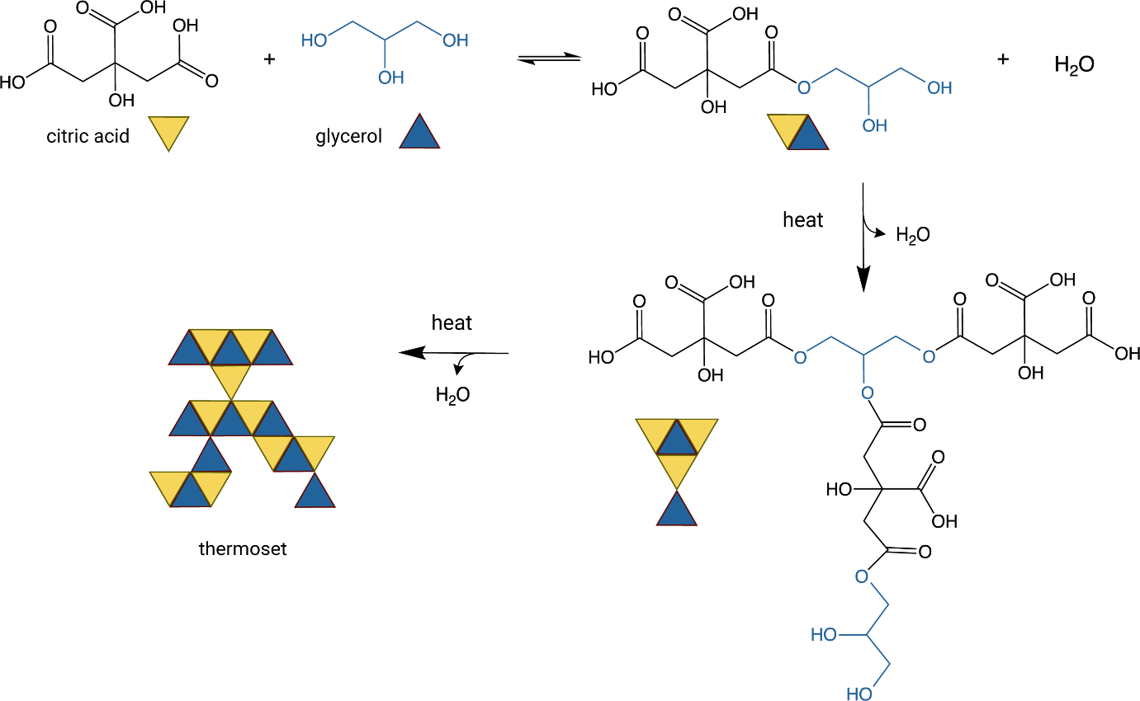
Figure 1: Polymer formation of polyester from reaction of citric acid and glycerol.

Bioplastic from tapioca starch and glycerol
A different plastic can be formed from starch and glycerol. In this case, ethanoic acid is used to break down the amylopectin branch and linear chains of amylose and dextrin. As there are no carboxylic acid groups in either glycerol or amylose, no ester bonds can be formed. Instead, a network of hydrogen bonds is formed between the alcohol groups in the glycerol molecules and the alcohol groups attached to the starch, as shown in figure 2. This gives flexibility to the polymers. Glycerol is known as a softener. This process does not require a long reaction time, or heating, as it is not a chemical reaction. The removal of water according to Le Chatelier’s principle is also not relevant.
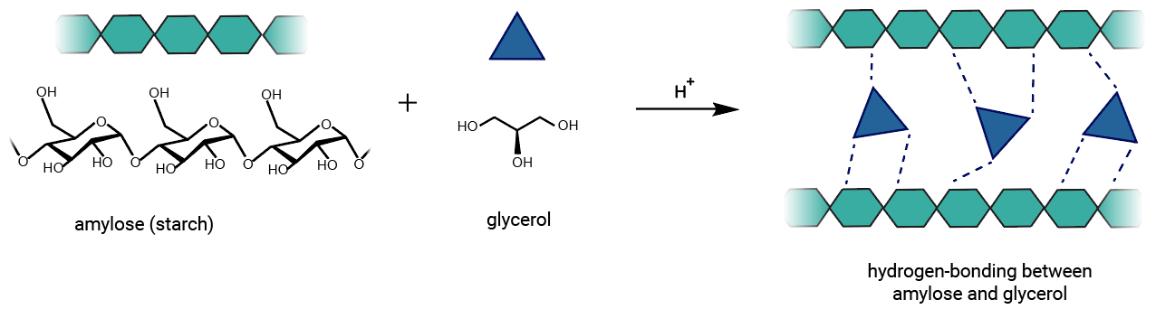
Figure 2: Hydrogen bonding between glycerol and amylose.

Bioplastic from tapioca starch and citric acid
A third type of plastic can be formed from starch and citric acid. Due to the presence of OH-groups in starch and carboxylic acid groups in citric acid, it is possible to form ester bonds. Heating to 100 °C, and a longer reaction time is necessary. Additionally, there is a possibility of hydrogen bond formation between the alcohol groups and carboxylic acid groups.

Lab equipment

Part 1A - lab session 1
- Balance
- Dropper
- 4 x 50 mL beakers
- Weighing boats
- 10 mL graduated measuring cylinder
- Glass stirring rod
- 3 aluminium boats/foil dishes
- Heating plate with magnetic stirrer
- Magnet
- Paper towels
- Permanent marker

Part 1B and 1C - lab session 2
- Spectrophotometer or colorimeter
- Timer
- 5 cuvettes
- 4 droppers
- 10 mL graduated measuring cylinder
- Paper
- Balance
- Scissors
- Small pieces of plastic e.g., PET or PLA

Chemicals

Part 1A
- Tapioca (arrowroot) starch
- Citric acid, C₆H₈O₇(s)
- 10 % (ca. 2 mol/L) ethanoic acid, CH₃COOH(aq)
- Distilled water
- Cooking oil
- Glycerol, C₃H₅(OH)₃(l)
- Yellow standard solution, (from colouring powder E102, tartrazine)

Part 1B and 1C
- 1.0 mol/L sodium hydroxide, NaOH(s) (corrosive, avoid skin and eye contact)

Safety Information
Mandatory personal protective equipment: goggles, lab coat, and for part C, gloves. Before starting, it is necessary to carefully read the instructions for safe work. The waste must be handled properly / according to the description in the risk assessment or teacher instructions.

Procedure

Part 1A: Preparation and synthesis of three bioplastics
All three bioplastics in part A are made during the same lab session.

Bioplastic 1 – bioplastic made of tapioca starch and citric acid
- Weigh out 3.2 g of tapioca starch and pour it into a 50 ml beaker.
- Weigh out 0.5 g of citric acid and pour it to the beaker.
- Add 10.0 ml of distilled water into the beaker.
- Add 1.0 ml of 10 % ethanoic acid/vinegar into the beaker.
- Stir the mixture well.
- Heat the beaker on the hotplate at 75 °C.
- While frequently stirring the mixture, continue heating until it starts to thicken (10–15 minutes). Lumps may develop if the temperature gets too high. If lumps begin to form, remove the beaker from the heat and stir the mixture. Once the mixture has thickened, remove the beaker from the hotplate.
- Add 1 ml of the yellow standard solution to the mixture (the colour solution) and stir.
- Mark the bottom of an aluminium foil dish with a 1 and your initials.
- Transfer the thick mixture to the labelled aluminium dish and heat it on the hotplate until the bioplastic material turns transparent (approximately 30 minutes).
- Remove the aluminium dish from the hotplate and allow the content to dry completely.

Bioplastic 2 - bioplastic made of tapioca starch and glycerol.
- Weigh out 1.5 g of glycerol in a 50 ml beaker.
- Weigh out 2.0 g of tapioca starch and add it to the beaker.
- Repeat points 3–11 from the method for bioplastic 1 (tapioca and citric acid) but make sure to mark the aluminium dish with a 2 along with your initials.

Bioplastic 3 - bioplastic made of glycerol and citric acid.
- Weigh out 2.0 g of glycerol into a 50 ml beaker.
- Weigh out 2.0 g of citric acid using a separate 50 ml beaker and add 2.0 ml of distilled water. Dissolve the citric acid by stirring either with a glass rod or a magnetic stirrer.
- Add 1 ml of the yellow standard solution to the citric acid solution.
- Add the coloured citric acid solution to the glycerol and stir until a homogeneous mixture is formed.
- Mark the bottom of an aluminium dish with a 3 and your initials.
- Grease the aluminium dish by using a piece of kitchen paper dipped in cooking oil, then pour in the mixture into the dish.
- Place the aluminium dish in an oven at 100 °C and let it stay for 2–7 days.

Part 1B: Qualitative observation of the degradation of a common plastic PET/PLA
Part 1B and 1C are done during the same lab session.
- Take PET/PLA plastic sample and chop it into small pieces. Add approximately 0.5 g of the chopped plastic into a 50 ml beaker.
- Add 10–15 mL of 1 mol/L NaOH to the beaker.
- At the end of the lab session observe any changes in the plastic sample.

Part 1C: Spectrophotometric analysis on the degradation of the bioplastic samples
- Weigh out approximately 0.1 g of your bioplastic. Cut it, with a pair of scissors, to an appropriate size (try to only use one piece that fits the cuvette you will use). Record the actual mass of the plastic sample you use.
- Fill 2/3 of a cuvette with 1 mol/L NaOH. Place the cuvette in the spectrophotometer and carry out a calibration at 425 nm. Remove the cuvette when the calibration is complete.
- Add the bioplastic sample from step 1 to the cuvette.
- Place the cuvette into the spectrophotometer and determine the absorbance at 425 nm. This reading is your measurement for time 0 min.
- Wear a laboratory glove or use a cuvette lid to cover the sample. Shake the sample for 3 seconds, and then set it aside for 5 minutes to allow the contents to settle. Place the cuvette in the spectrophotometer and read the absorbance at 425 nm.
- Repeat steps 4 and 5 every five minutes until the bioplastic is no longer visible (ca. 60 minutes).
NOTE: Repeat points 3–6, for all three samples.

Questions for Discussion
After part 1A (lab session 1):
- Observe the samples and record which properties the bioplastics have after drying.
- Are there big differences between the samples? How do you think the bonding in the bioplastics might affect the properties that you observe?
- Rank the samples in order of how quickly you think they might degrade. Explain your reasoning.
- Why is the food colouring added?

After part 1B and 1C (lab session 2):
- Compare the degradation of the bioplastic samples to the PLA or PET plastic samples.
- At the end of part 1 you ranked the bioplastic samples in order of how quickly you thought they would degrade. Do your results agree with this prediction? Explain.
- Why can we describe the plastic we made in this experiment as greener than the common polymer/plastic PET?
- Discuss applications where biodegradable plastic could replace the non-biodegradable plastic.

Results and Discussion
Present the experimental data from part 1C in a table and then plot a graph showing absorbance versus time for all the bioplastic samples.
 | Bioplastic 1: Tapioca starch and citric acid | Bioplastic 2: Tapioca starch and glycerol | Bioplastic 3: Citric acid and glycerol
Time (min) | Absorbance at 425 nm | Absorbance at 425 nm | Absorbance at 425 nm
0
5
10
15
20
25
30
35
40
45
50
55
60

Conclusion
Summarize your findings from the Results and Discussion phase.

Student Worksheet – part 2

Evaluation of experimental work with green chemistry metrics
Evaluate the experiment the Synthesis and analysis of bioplastics using green chemistry metrics. In this activity you will
- determine the hazards of the substances used in the experiment, thereby you will learn how to obtain and use safety data sheets and develop a practical understanding of hazard (H) and precautionary (P) statements
- determine the value of perceived greenness of the experiment, thereby you will be introduced to the 12 principles of green chemistry
- construct the green star of the experiment, thereby you will present the data obtained using graphical means to get a better overview of greenness of the experiment.
Follow the instructions below and use appendix 2–4 to help with the activity.

1. Determine the hazards of the substances used in experimental work
- In table 1, insert the names of the chemical compounds included in the experiment in the first column.
- For each chemical used, consult the safety data sheets you can obtain via the QR code in the risk assessment and write the hazard codes of each chemical in the second column.
- Use "Criteria to classify the hazards of substances” (appendix 2) to obtain scores* (1–3) attributed to health, environment, and physical hazards for each chemical used in the experiment. Insert the obtained scores in the appropriate (third/fourth/fifth) column. If no hazard code is assigned for a chemical, assign a score of 1.
Table 1: Hazards of the substances used in experimental work, according to the protocol described in the procedure (part A, part B, part C).
 | Hazard code | Scores (S) attributed to hazards*
 |  | Health | Environment |  | Physical
Part A: Preparation and synthesis of three bioplastics.
Part B: Observation of the degradation of a common plastic PET/PLA
Part C: Spectrophotometric analysis on the degradation of the bioplastic samples
* Scores (S) attributed to hazards on a scale from 1 (low hazard) to 3 (high hazard)

2. Determine the value of perceived greenness
- To fill table 2, see the appendix 2 “Green chemistry principles and assessment criteria for the value of perceived greenness (V)”.
- Decide the number of principles (e.g., 6 or 10 principles) that provides the most meaningful evaluation of perceived greenness of the experiment.
- The value (V) of perceived greenness can be derived from the appendix 2–4. V ranges from 1 (minimum) to 3 (maximum). Write NA when non applicable.
Table 2: Green chemistry principles and the value V of perceived greenness, to construct the green star of the experimental work described in the over-all procedure (part A-C).
Green Chemistry Principle | V | Explanation
P1 – prevention
P2 – atom economy*
P3 – less hazardous chemical synthesis*
P4 – designing safer chemicals**
P5 – safer solvents and auxiliary substances
P6 – increase energy efficiency
P7 – use renewable feedstocks
P8 – reduce derivatives*
P9 – catalysts*
P10 – design for degradation
P11 – real-time analysis for pollution prevention**
P12 – safer chemistry for accident prevention
* Applicable when using 10 or 12 Principles. ** Applicable only when using all 12 Principles

3. Construction of the green star
With the construction of a green star present the results of the greenness assessment of experimental protocols you have conducted.
- If you are constructing the green star on paper, colour the radar chart shown in figures 1a–c. Colour the area corresponding to a specific principle (e.g., P1, P2, etc.) based on the determined value V in table 2.
- If you have a computer, you can construct the green star in Excel and insert a copy of the green star in your worksheet.
  - Open appendix 1 (Excel file) and select “Green star (10 principles)”.
  - Use your results from table 2 to fill in the data in the green cells.
  - Copy the image of your green star and replace the image below.

Figure 1: Greenness assessment of the experimental work Synthesis and Analysis of Bioplastics

4. Reflect on the results of the evaluation of experimental protocols with green chemistry metrics
What are the advantages and disadvantages of bioplastics?

References
Anastas, P. & Eghbali, N. (2010). Green chemistry: Principles and practice. Chemical society reviews, Vol. 39
Jegstad, K. M. & Sinnes, A. T. (2015). Chemistry Teaching for the Future: A model for secondary chemistry education for sustainable development. International journal of Science Education Vol.37
Knutson, C. M., Hilker, A.P., Tolsyka, Z. P., Anderson, C. B., Wilbon, P. A., Mathers, R. T., Wentzel, M. T., Perkins, A. L., Wissinger, J. E. (2019). Dyeing to Degrade: A Bioplastics Experiment for College and High School Classrooms. J. Chem. Educ. 96, 2565−2573, 10.1021/acs.jchemed.9b00461
Parker, L. (2018). A Whopping 91 Percent of Plastic Isn’t Recycled. National Geographic. https://education.nationalgeographic.org/resource/whopping-91-percent-plastic-isnt-recycled
Ribeiro, M. G. T., Costa, D. A., & Machado, A. A. (2010). “Green Star”: a holistic Green Chemistry metric for evaluation of teaching laboratory experiments. Green Chemistry Letters and Reviews, 3(2), 149-159. https://doi.org/10.1080/17518251003623376
Ribeiro, M. G. T., & Machado, A. A. (2014). Green star construction. http://educa.fc.up.pt/documentosQV/EV/Construction%20of%20Green%20Star_6_points_GSAI.xlsx

A film (5.45 minutes) about plastics: https://education.nationalgeographic.org/resource/science-101-plastics
https://www.eea.europa.eu/publications/the-plastic-waste-trade-in

