Student Worksheet – part 1

Synthesis of Biodiesel from Vegetable Oil

Topics
hydrocarbons, organic oxygen compounds (alcohols, esters)

Objectives
According to the Slovenian Chemistry Curriculum for Primary School (Chemistry Curriculum for Primary School, 2011).
- Students learn about oil and natural gas as key sources of organic compounds and non-renewable energy sources.
- Students are encouraged to develop ideas related to prevention or reduction of impacts of hydrocarbons and their derivatives on the environment and the importance of waste recycling.
- Students study the properties of the main groups of organic oxygen compounds and relate them to use.
- Students are encouraged to develop experimental-research skills.
- Students understand the interdependence of the structure, properties, and uses of the chemical compounds.
- Students develop responsible attitudes towards use of chemical compounds and responsibility for health and the environment (chemical safety).
- Students are encouraged to observe systematically and use observations as a source of data.

Introduction
Unlike other renewable energy sources, biomass can be converted directly into liquid fuels, called "biofuels". The two most common types of biofuels in use today are bioethanol (from sugar or starch-containing raw materials e.g., rapeseed oil, soybean, sunflower, corn oil, maize) and biodiesel (from vegetable oil e.g., rapeseed oil, soybean, sunflower, corn oil).
The biodiesel we focus on in this material has become an alternative fuel used in diesel engines. Using biodiesel represents many advantages, as it is a biodegradable, non-toxic and environmentally friendly fuel. Burning biodiesel produces similar carbon dioxide emissions to fossil fuels, but the carbon dioxide emitted returns to atmospheric carbon dioxide absorbed by plants through photosynthesis, and biofuels as such are considered carbon neutral. However, other factors must also be considered, e.g., emissions from growing the feedstock, transport, processing, emissions from the change in land use of the area where the fuel feedstock is grown.
Biodiesel is made through a chemical process called transesterification. The process leaves behind two main products – fatty acid alkyl esters, most often methyl or ethyl esters (biodiesel), and glycerol (used in a variety products).

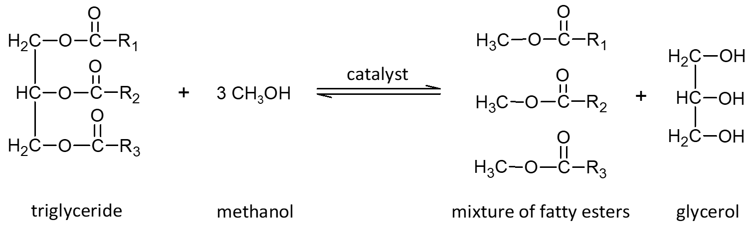
Figure 1: Transesterification reaction between glyceride and alcohol, in the presence of a catalyst.

Lab equipment
- 2 x 250 mL separating funnel
- 2 x 100 mL measuring cylinder
- 2 x 50 mL graduated cylinder
- 2 x 50 mL beaker
- 2 x ring stand
- additional items as requested by students

Chemicals
- 100 mL used (waste) sunflower oil
- 30 mL methanol
- 2 mL 9 M potassium hydroxide – catalyst
- 10 mL distilled water
- additional items as requested by students

Safety Information
Mandatory personal protective equipment: goggles, lab coat, and gloves. Before starting, it is necessary to carefully read the instructions for safe work. The waste must be handled properly /according to the description in the risk assessment or teacher instructions.

Procedure
- Assemble the iron ring on the stand.
- Place the separating funnel in the iron ring. Remove the stopper and make sure that the tap is closed.
- Pour 100 mL of used (waste) sunflower oil into a 250 mL separation funnel and carefully add 15 mL of methanol.
- Cautiously add 1 mL of 9 M potassium hydroxide dropwise.
- Shake the funnel gently, vent it, and repeat this step until no more gas escapes. This will take about 5 minutes.
- Place the separating funnel on the ring and let stand overnight to form two layers.
- Collect the lower layer, glycerol, in a measuring cylinder and record the volume.
- Keep the biodiesel in the separation funnel and carefully add 10 mL of distilled water to the funnel.
- Shake the separation funnel very gently four times. Soaps are formed during the reaction, which can foam the contents when mixed quickly.
- Wait for two layers to form and then collect the bottom layer, consisting of soap and distilled water, in a 50 mL beaker.
- Pour the biodiesel from the top of the funnel into the measuring cylinder and measure the volume.
- Transfer the biodiesel from the measuring cylinder to a 250 mL beaker and allow to stand overnight to clear.

Questions for discussion
- What yield of biodiesel did you obtain?
- What is biodiesel?
- List other vegetable oils that could be used in synthesis of biodiesel.
- Potassium hydroxide is used in the biodiesel synthesis process. From the chemical reaction equation (fig. 1), determine the role of the potassium hydroxide.
- List three factors that could affect the yield of synthesized biodiesel.

Results and Discussion
Organize, interpret, and communicate your experimental results using tables, graphs and/or charts.

Conclusion
Summarize your findings presented in the Results and Discussion phase.

Student Worksheet – part 2

Evaluation of experimental work with green chemistry metrics
Evaluate the experiment Synthesis of biodiesel from vegetable oil using green chemistry metrics. In this activity you will
- determine the hazards of the substances used in the experiment, thereby you will learn how to obtain and use safety data sheets and develop a practical understanding of hazard (H) and precautionary (P) statements
- determine the value of perceived greenness of the experiment, thereby you will be introduced to the 12 principles of green chemistry
- construct the green star of the experiment, thereby you will present the data obtained using graphical means to get a better overview of greenness of the experiment.
Follow the instructions below and use appendix 2–4 to help with the activity.

1. Determine the hazards of the substances used in experimental work
- In table 1, insert the names of the chemical compounds included in the experiment in the first column.
- For each chemical used, consult the safety data sheets you can obtain via the QR code in the risk assessment and write the hazard codes of each chemical in the second column.
- Use "Criteria to classify the hazards of substances” (appendix 2) to obtain scores* (1–3) attributed to health, environment, and physical hazards for each chemical used in the experiment. Insert the obtained scores in the appropriate (third/fourth/fifth) column. If no hazard code is assigned for a chemical, assign a score of 1.
Table 1: Hazards of the substances used in experimental work. In this example: Synthesis of biodiesel form vegetable oil.
 | Hazard code | Scores (S) attributed to hazards*
 |  | Health | Environment |  | Physical
Stoichiometric reagents
Solvents and Auxiliary Substances
Product
Waste
* Scores (S) attributed to hazards on a scale from 1 (low hazard) to 3 (high hazard)

2. Determine the value of perceived greenness
- To fill table 2, see the appendix 4 “Green chemistry principles and assessment criteria for the value of perceived greenness (V)”.
- Decide the number of principles (e.g., 6 or 10 principles) that provides the most meaningful evaluation of perceived greenness of the experiment.
- The value (V) of perceived greenness can be derived from appendix 2. V ranges from 1 (minimum) to 3 (maximum). Write NA when non applicable.
Table 2: Green chemistry principles and the value of perceived greenness to construct the green star of the experimental work. In this example: Synthesis of biodiesel form vegetable oil.
Green Chemistry Principle | Value of perceived greenness (V) | Explanation (optional)
P1 – prevention
P2 – atom economy*
P3 – less hazardous chemical synthesis*
P4 – designing safer chemicals**
P5 – safer solvents and auxiliary substances
P6 – increase energy efficiency
P7 – use renewable feedstocks
P8 – reduce derivatives*
P9 – catalysts*
P10 – design for degradation
P11 – real-time analysis for pollution prevention**
P12 – safer chemistry for accident prevention
* Applicable when using 10 or 12 Principles. ** Applicable only when using all 12 Principles

3. Construction of the green star
With a construction of a green star present the results of the greenness assessment of experimental protocol.
- If you are constructing the green star on paper, colour the radar chart shown in figure 1. Colour the area corresponding to a specific principle (e.g., P1, P2, etc.) based on the determined value V in table 2.
- If you have a computer, you can construct the green star in Excel and insert a copy of the green star in your worksheet.
  - Open appendix 1 (Excel file) and select “Green star (10 principles)”.
  - Use your results from table 2 to fill in the data in the green cells.
  - Copy the image of your green stars and replace the images bellow.

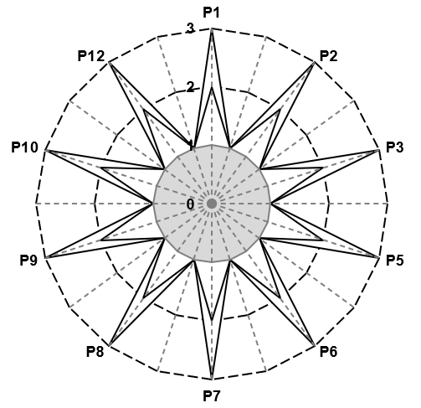
Figure 1: Greenness assessment of the experimental work.

4. Consider Further possibilities to optimize the experimental protocol
Could methanol be substituted with another alcohol? Could a different catalyst with less hazardous properties be used?

References
Ribeiro, M. G. T., Costa, D. A., & Machado, A. A. (2010). “Green Star”: a holistic Green Chemistry metric for evaluation of teaching laboratory experiments. Green Chemistry Letters and Reviews, 3(2), 149-159. https://doi.org/10.1080/17518251003623376
Ribeiro, M. G. T., & Machado, A. A. (2014). Green star construction. http://educa.fc.up.pt/documentosQV/EV/Construction%20of%20Green%20Star_6_points_GSAI.xlsx

