Teacher Guide – part 1

Synthesis of Bioplastic from Banana Peel
This teaching unit is designed as Step-by-Step Instruction. Students will find out more about bioplastic synthesis using banana peels through experimental work and by using textbooks and other available sources.

Students’ Age
The experiment is suitable for students in the 9th grade (14–15 years old).

Time Required
90 min

Curricular relevance
According to the Slovenian Chemistry Curriculum for Primary School (Chemistry Curriculum for Primary School, 2011).
- Students define polysaccharides as natural polymers.
- Students understand the importance and impact of organic oxygen compounds on everyday life and the environment.
- Students are encouraged to develop experimental-research skills.
- Students understand the interdependence of the structure, properties, and uses of chemical compounds.
- Students develop a responsible attitude towards use of chemical compounds and responsibility for health and the environment (chemical safety).
- Students are encouraged to observe systematically and use observations as a source of data.

Introduction
Plastic materials (plastics) contain artificial polymers as their main component, which are characterised by high molecular weights. Due to the ease of processing and the numerous possibilities for manufacturing low-cost products that increase the standard of living, quality and comfort of life, polymeric materials have successfully penetrated the world markets. Depending on their origin, polymers can be divided into natural (e.g., proteins, polysaccharides, and DNA molecules) and artificial or synthetic.
Petrochemistry is a field of chemistry that includes technical processes and chemical syntheses for the industrial extraction of products from oil and natural gas. Currently, almost all polymeric materials are produced by the petrochemical industry i.e., they are produced from fossil (non-renewable) sources. Due to the mass consumption of disposable plastic products intended for very short-term use (e.g., plastic pots, plastic bags), the amount of plastic waste is increasing.
Some see bioplastics as an alternative option. The current definition refers to bioplastics as biodegradable plastics and/or plastics made from renewable raw materials. According to this definition, bioplastics also include plastics that are not biodegradable but are made from a renewable resource (e.g., polyethylene from sugar cane).
Depending on the raw material, bioplastics are divided into:
- bioplastics from renewable resources
- bioplastics from fossil resources
- bioplastics from a mixture of renewable and fossil resources
Polymers based on renewable resources can be divided into three categories:
- polymers extracted/removed directly from biomass: polysaccharides, e.g., starch and cellulose; proteins, e.g., casein and gluten
- polymers produced by classical chemical syntheses using monomers from renewable raw materials (e.g., polyethylene)
- polymers obtained with the help of microorganisms or genetically modified bacteria
Due to its wide availability, low cost, renewability and biodegradability, starch is often used to produce bioplastics. Many previous studies have been conducted using starch as a natural biopolymer. Starch consists of a long chain of two glucose units linked together, namely branched polymerised amylopectin and amylose, which give it a granular structure. Starch can behave like a thermoplastic in the presence of plasticisers and with the application of heat and mechanical treatment.
If not disposed of properly the amount of food waste from various sources can be a burden on the environment. Therefore, implementing a biorefinery platform for food waste is an ideal option (e.g., producing value-added products while reducing the amount of waste). It is expected that the implementation of such a process will reduce the production costs of biodegradable plastics (e.g., compared to traditional production routes using overpriced pure substrates (e.g., glucose)).
One of the most common starchy wastes is banana peels. In some parts of the world, the disposal of tonnes of banana peel is a problem, especially in industries that produce banana products such as banana cakes, banana crisps, banana fritters, and more. These industries use the banana flesh as raw material and dispose of the peels at the end of the process.
Banana peels contain a high percentage (about 18.5 %) of starch. As the banana peels ripen, the glucose content increases. Therefore, banana peels that are not too ripe can be proposed as a suitable resource to produce bioplastics.
Although food waste is a good feedstock to produce bioplastics, it needs to be pre-treated to improve or change the physical, chemical, and biological properties. Successful conversion processes refer to the partial or complete release of monomers from the food waste (e.g., lignocellulosic components) with increasing accessibility of proteins, lipids, and polysaccharides (e.g., starch and cellulose) for subsequent enzymatic hydrolysis and fermentation. In addition, multiple methods can be integrated into a single treatment system for better performance.

Risk Assessment
List significant hazards | Describe what could happen | Precautionary measures | Measures to be taken if something goes wrong
0.2 M sodium metabisulfite | H302 Harmful if swallowed.  H313 May be harmful to skin.  H319 Causes serious eye irritation. | P281 Wear protective equipment for hands, eyes, face, and respiratory tract.  P305 + P351 + P338 IF IN EYES: Rinse cautiously with water for several minutes. Remove contact lenses, if present and easy to do. Continue rinsing.
0.2 M hydrochloric acid | H290 May be corrosive to metals. | P234 Keep only in original packaging.  P390 Absorb spillage to prevent material damage.
0.2 M sodium hydroxide | H290 May be corrosive to metals.  H315 Causes skin irritation.  H319 Causes serious eye irritation | P234 Keep only in original packaging.  P264 Wash skin thoroughly after handling.  P280 Wear protective gloves/ eye protection/ face protection.  P302 + P352 IF ON SKIN: Wash with plenty of water.  P305 + P351 + P338 IF IN EYES: Rinse cautiously with water for several minutes.  Remove contact lenses, if present and easy to do. Continue rinsing.  P332 + P313 If skin irritation occurs: Get medical advice/ attention.

Disposal and any other comments | Reaction products should be disposed in accordance with instructions written in SDS and local/regional/national/international regulations.  Students should wear personal protective equipment (gloves, goggles, and lab coat).
In case of emergency | In case of emergency call 112 or personal doctor.

Date of assessment | 13-2-2023 | Written by | CheSSE | Class / lesson | EXAMPLE

Example answers to the questions (where relevant)
- What is bioplastic? Answers will vary. Bioplastic is defined as biodegradable plastic and/or plastic from renewable sources. According to this definition, bioplastic also include plastic that is not biodegradable, but are made from a renewable resource (e.g., polyethylene from sugar cane). Depending on the source, bioplastics are divided into (1) bioplastics from renewable sources, (2) bioplastics from fossil sources and (3) bioplastics from a mixture of renewable and fossil resources.
- List other plant sources that could be used in synthesis of bioplastic. Answers will vary. Sugar cane, corn, potato peels, etc.
- What is the role of glycerol in the synthesis of bioplastic? Glycerol is added as a plasticizer or dispersant, additive that increase the plasticity or fluidity of a material.
- List at least three factors that could possibly affect the properties (e.g., biodegradation, strength, elasticity) of synthesized bioplastic. Answers will vary. Some factors affecting the properties of synthesized bioplastic are the ripeness of banana peels, method of pre-treatment of food waste (banana peels), the amount and type of plasticizer etc.

Results And Discussion (Example)
Students organize, interpret, and communicate experimental results using tables, graphs and/or charts.
Table 1: Results of synthesis of bioplastic from banana peel
Observations | Conclusions
Preparation of banana paste from banana peels  The banana paste obtained from banana peels treated with 0.2 M solution of sodium metabisulphite for 45 minutes was smooth and brown in colour. | Preparation of banana paste from banana peels  Adding a solution of sodium metabisulphite should improve the shelf-life of the plastic and prevent the microbial growth in the films, as sodium metabisulphite is antioxidant and food preservative.
Preparation of bioplastic (film) from banana paste  After adding the glycerol, 0.5 M solution of hydrochloric acid and 0.5 M solution of sodium hydroxide and heating the mixture, it thickened.  After drying, the bioplastic film was obtained.  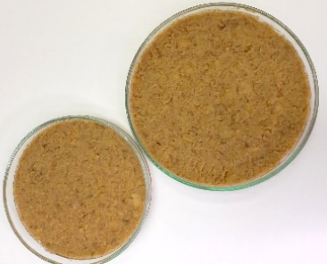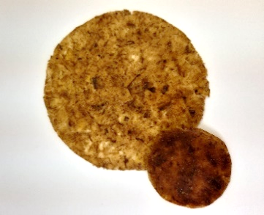 | Preparation of bioplastic (film) from banana paste  The hydrochloric acid was used in the hydrolysis of amylopectin, which was needed to aid the process of film formation due to the H-bonding amongst the chains of glucose in starch, since amylopectin restricts the film formation. The sodium hydroxide used in the experiment was simply used to neutralize the pH of the medium. The glycerol was used as a plasticizer, an additive to develop or improve the plasticity of a material.
During this phase, students present and interpret their research results. Students also evaluate their experimental work using green chemistry metrics (see student worksheet – part 2). Interaction among student groups is important as well as collection of information that will be utilized during the Conclusion phase.
The evaluation of the experimental work – synthesis of bioplastic from banana peels using green chemistry metrics – shows that the experiment could be optimised, especially regarding principles 1, 5, 10 and 12. In the future, sodium bicarbonate could be used as a preservative for the plastic instead of sodium metabisulphite, although it requires higher temperatures (350˚C) to be efficient.

Conclusion (example)
In this phase we summarize the results presented in the Communicating the Results phase.
Waste banana peels can serve as an abundantly available, inexpensive, and environmentally friendly organic material. Using banana peels to create bioplastic instead of relying on petroleum-based plastics can help reduce the consumption of non-renewable resources. In the future, it would be interesting to investigate how different parameters affect the properties (e.g., water solubility, water absorption capacity, biodegradability) of the synthesised bioplastic.

Teacher Guide – part 2

Evaluation of experimental work with green chemistry metrics (sample results)
Evaluate the experiment Synthesis of bioplastic from banana peel using green chemistry metrics. In this activity you will
- determine the hazards of the substances used in the experiment, thereby you will learn how to obtain and use safety data sheets and develop a practical understanding of hazard (H) and precautionary (P) statements
- determine the value of perceived greenness of the experiment, thereby you will be introduced to the 12 principles of green chemistry
- construct the green star of the experiment, thereby you will present the data obtained using graphical means to get a better overview of greenness of the experiment.
Follow the instructions below and use Appendix 2, 3, and 4 to help with the activity.

1. Determine the hazards of the substances used in experimental work
- In Table 1, insert the names of the chemical compounds included in the experiment in the first column.
- For each chemical used, consult the safety data sheets you can obtain via the QR code in the risk assessment and write the hazard codes of each chemical in the second column.
- Use appendix 2 to obtain scores* (1–3) attributed to health, environment, and physical hazards. Insert the obtained scores in the appropriate column. If no hazard code is assigned for a chemical, assign a score of 1.
Table 1: Hazards of the substances used in experimental work. In this example: Synthesis of bioplastic from banana peel.
 | Hazard code | Scores (S) attributed to hazards*
 |  | Health | Environment |  | Physical
banana peels | – | 1 | 1 | 1
sodium metabisulfite  (CAS 7681-57-4) | H302, H313, H319 | 2 | 1 | 1
0.2 M hydrochloric acid | – | 1 | 1 | 1
0.2 M sodium hydroxide | H290, H315, H319 | 2 | 1 | 2
glycerol  (CAS 56-81-5) | – | 1 | 1 | 1
water | – | 1 | 1 | 1
bioplastic |  | 1 | 1 | 1
* Scores (S) attributed to hazards on a scale from 1 (low hazard) to 3 (high hazard)

2. Determine the value of perceived greenness
- To fill table 2, see the Green Chemistry Principles and Criteria for assessment of the value of perceived greenness (appendix 2).
- Decide the number of principles (e.g., 6 or 10 principles) that provides the most meaningful evaluation of perceived greenness of the experiment.
- The value (V) of perceived greenness can be derived from appendix 2. V ranges from 1 (minimum) to 3 (maximum). Write NA when non applicable.
Table 2: Green chemistry principles and the value of perceived greenness to build the green star of the experimental work. In this example: Synthesis of bioplastic from banana peel.
Green Chemistry Principle | Value of perceived greenness (V) | Explanation (optional)
P1 – prevention | 2 | sodium metabisulfite solution, sodium hydroxide solution
P2 – atom economy*
P3 – less hazardous chemical synthesis*
P4 – designing safer chemicals**
P5 – safer solvents and auxiliary substances | 2 | sodium metabisulfite solution, sodium hydroxide solution
P6 – increase energy efficiency | 2 | room pressure and temperature between 0 and 100 ºC when heating is needed
P7 – use renewable feedstocks | 2 | banana peels
P8 – reduce derivatives*
P9 – catalysts*
P10 – design for degradation | 2 | sodium metabisulfite solution
P11 – real-time analysis for pollution prevention**
P12 – safer chemistry for accident prevention | 2 | sodium metabisulfite solution, sodium hydroxide solution
* Applicable when using 10 or 12 Principles. ** Applicable only when using all 12 Principles

3. Construction of the green star
The green star presents the results of the greenness assessment of the experimental protocol.
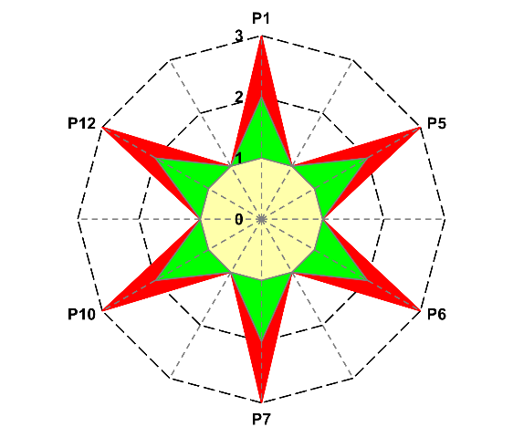
Figure 2: Greenness assessment of the experimental work.

4. Reflect on the results of the evaluation of experimental protocols with green chemistry metrics

References
MIZS (Ministry of Education, Science and Sport of the Republic of Slovenia). (2011). Program osnovna šola. Kemija. Učni načrt. https://www.gov.si/assets/ministrstva/MIZS/Dokumenti/Osnovna-sola/Ucni-nacrti/obvezni/UN_kemija.pdf
Ribeiro, M. G. T., Costa, D. A., & Machado, A. A. (2010). “Green Star”: a holistic Green Chemistry metric for evaluation of teaching laboratory experiments. Green Chemistry Letters and Reviews, 3(2), 149-159. https://doi.org/10.1080/17518251003623376
Ribeiro, M. G. T., & Machado, A. A. (2014). Green star construction. http://educa.fc.up.pt/documentosQV/EV/Construction%20of%20Green%20Star_6_points_GSAI.xlsx

